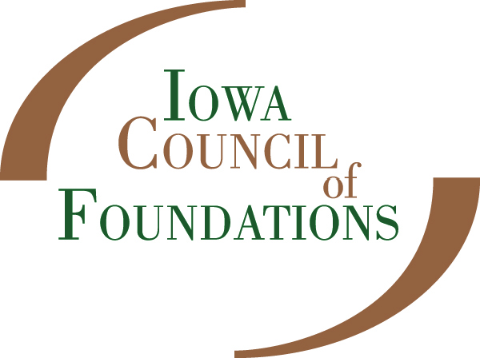

Community Foundation Capacity Building Grant Program
End-of-Year Report

The Iowa Council of Foundation’s Capacity Building Grants Program supports opportunities for qualified community foundations and their affiliates to engage in activities that increase their ability for sustainable endowment growth/building. Capacity building grants provide community foundations with support to implement projects or programs necessary to enhance their organizational capacity and address important issues of fund development and effectiveness.

Reporting Procedure:
Please answer the following questions, as well as include budget detail noting how the funds for your Capacity Building Grant were expended.
- Please describe the project that was funded. (100 words or less)
- What were the Successes and Accomplishments of the project? (200 words or less)
- What were the Challenges in executing this project?(200 words or less)
- What are the lessons your organization has Learned from this project and what, if any, changes would you make to a similar project in the future? (200 words or less)
End-of-Year Grant Reports may be submitted via email to Michele Walstrom, Community Foundations Services Coordinator, mwalstrom@iowacounciloffoundations.org. Questions regarding the report may also be directed to Michele.

