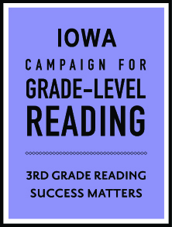
Iowa Campaign for Grade-Level Reading Convening
October 4, 2018 | 10 am – 3 pm
Greater Des Moines Botanical Garden | Swartz Room

10:00 – 10:30 am Welcome and Introductions
- Name, role, community
- One thing you have been thinking about since GLR week or one thing you are excited about in your local Campaign right now.

10:30 – 11:15 am Remarks from Ralph Smith
- Reflections from GLR Week
- Campaign Updates – new online system, sustainable scale cohort, etc.
- Looking ahead to 2019, what can we expect to see/hear from the Campaign.
- What should our communities be thinking about?

11:15 am – 12:15 pm Children’s Policy Panel
- Lisa Cushatt, Program Manager, Central Iowa Aces 360
- Mary Nelle Trefz, Health Policy Associate, Child and Family Policy Center
- Chaney Yeast, Director of Government Relations, Blank Children’s Hospital
- Deann Cook, Executive Director, United Ways of Iowa

12:15 – 1:15 pm Networking Lunch

1:15 – 2:00 pm Trauma-Informed Care & Resilience: Updates from GLR Communities
- Suzanne Mineck, President, Mid-Iowa Health Foundation
- Laura Columbus, Coordinator-Education Initiatives, United Way of East Central Iowa

2:00 – 2:45 pm Iowa’s Integrated Data System Project
Dr. Heather Rouse, Assistant Professor, Iowa State University

2:45 – 3:00 pm Wrap Up
Becky Miles-Polka, Iowa State Lead, Campaign for Grade-Level Reading

