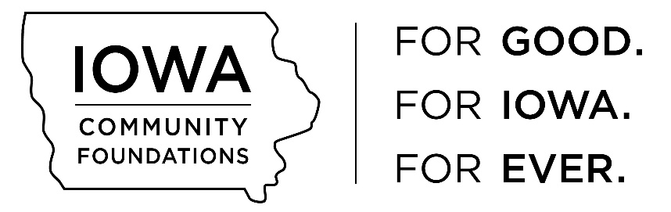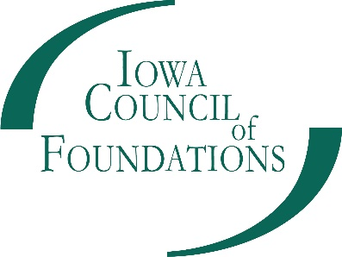

Community Foundation Capacity Building Grant Program
Guidelines

Purpose
The Iowa Council of Foundation’s Capacity Building Grants Program will support opportunities for qualified community foundations and their affiliates to engage in activities that increase their ability for sustainable endowment growth/building. Capacity building grants will provide community foundations with support to implement projects or programs necessary to enhance their organizational capacity and address important issues of fund development and effectiveness.
Examples of capacity building projects include:
- Planning activities: e.g., organizational assessments, strategic planning, fund development, communications/marketing, events—all tied to a fundraising strategy.
- Board development in endowment growth: may include activities such as leadership training, defining the role of the board, and strengthening volunteer role in endowment growth.
- Strategic Relationships: building collaborative relationships with professional advisors and/or nonprofit development staff.
- Internal operations: improvements to financial management, volunteer management; or staff-like support for affiliate growth.
- Technology Improvements: IT capacity through upgrades to hardware and software, networking, websites, and staff training to optimize use of technology.
- Professional development: staff or affiliate volunteers attendance at national conferences; Local trainings, online webinars for staff or volunteers around endowment growth.

Eligibility and Guidelines
This grant application opportunity is open to any qualified Iowa community foundation and projects must focus on the host foundation’s work with their affiliates. Funds may be used for opportunities or organizational challenges that, if addressed, would have a clear, positive impact on the affiliate community foundation’s ability to build endowment funds. Additional information regarding program requirements is listed below:
- Interested parties must submit a Capacity Building Program PRE-Application Form. The forms will be available beginning February 1 and are due by March 1, at which time the full application will be available. The Pre-Application Form will allow ICoF staff to review the planned program submission and provide feedback to the potential grantee, prior to submitting the Capacity Building Grant Full Application by April 1.
- Requesting organizations must demonstrate a 50% match to the requested funds (ex. Request = $5,000; required match = $2,500.) Acceptable cash match contributions include:
  - Funds contributed by the host or affiliate
  - Funds contributed by a third-party
- All grant application submissions must include the completed application as a PDF using this template, along with a detailed program/project budget.
- Grant applications must also include a one-page cover letter signed by both the affiliate organization/s and the host community foundation.
- Collaborative projects between one or more affiliates are encouraged as well as applications that provide clear strategies for growing endowment funds as opposed to mere administrative support.
- Grant applicants are eligible to apply for funding once per fiscal year in the grant cycle. A fiscal year is July 1 through June 30 the following year.

Program Terms and Limitations
The period in which the grantee may invest grant funds and the period in which the grantee is required to report with respect to the use of grant funds will run from June 1, 2019 through June 30, 2020. Capacity Building grant recipients will be required to submit year-end reports (template provided by ICoF) on how the grant funding was utilized to achieve their goals in endowment growth. Additionally, funding support per recipient is anticipated to be in the range of $1,000-$15,000. This support must be used to provide continued, new or expanded capacity building specifically focused on asset development to promote endowment growth. Priority given to grants focused on capacity building for affiliate community foundations.

Applications
The Capacity Building Program PRE-Application Form will be available through a link on www.iowacounciloffoundations.org in the Community Foundations tab, Grant Opportunities beginning February 1. The final grant application for the Capacity Building grant program will be distributed on a rolling basis to the foundations that have pre-qualified, via email.

Submission Deadline
The submission deadline for the PRE-Application is Friday, March 1, 2019. Reviews and recommendations will be made within 10 days following receipt. The final grant application will be due April 1, 2019. No applications will be received after 5:00 pm on this date. Grant recipients will be announced in May and recipients will receive their grant funding shortly thereafter.

For more information
Please contact Michele Walstrom, Community Foundations Services Coordinator, by phone at (515) 989-1188 or email at mwalstrom@iowacounciloffoundations.org

