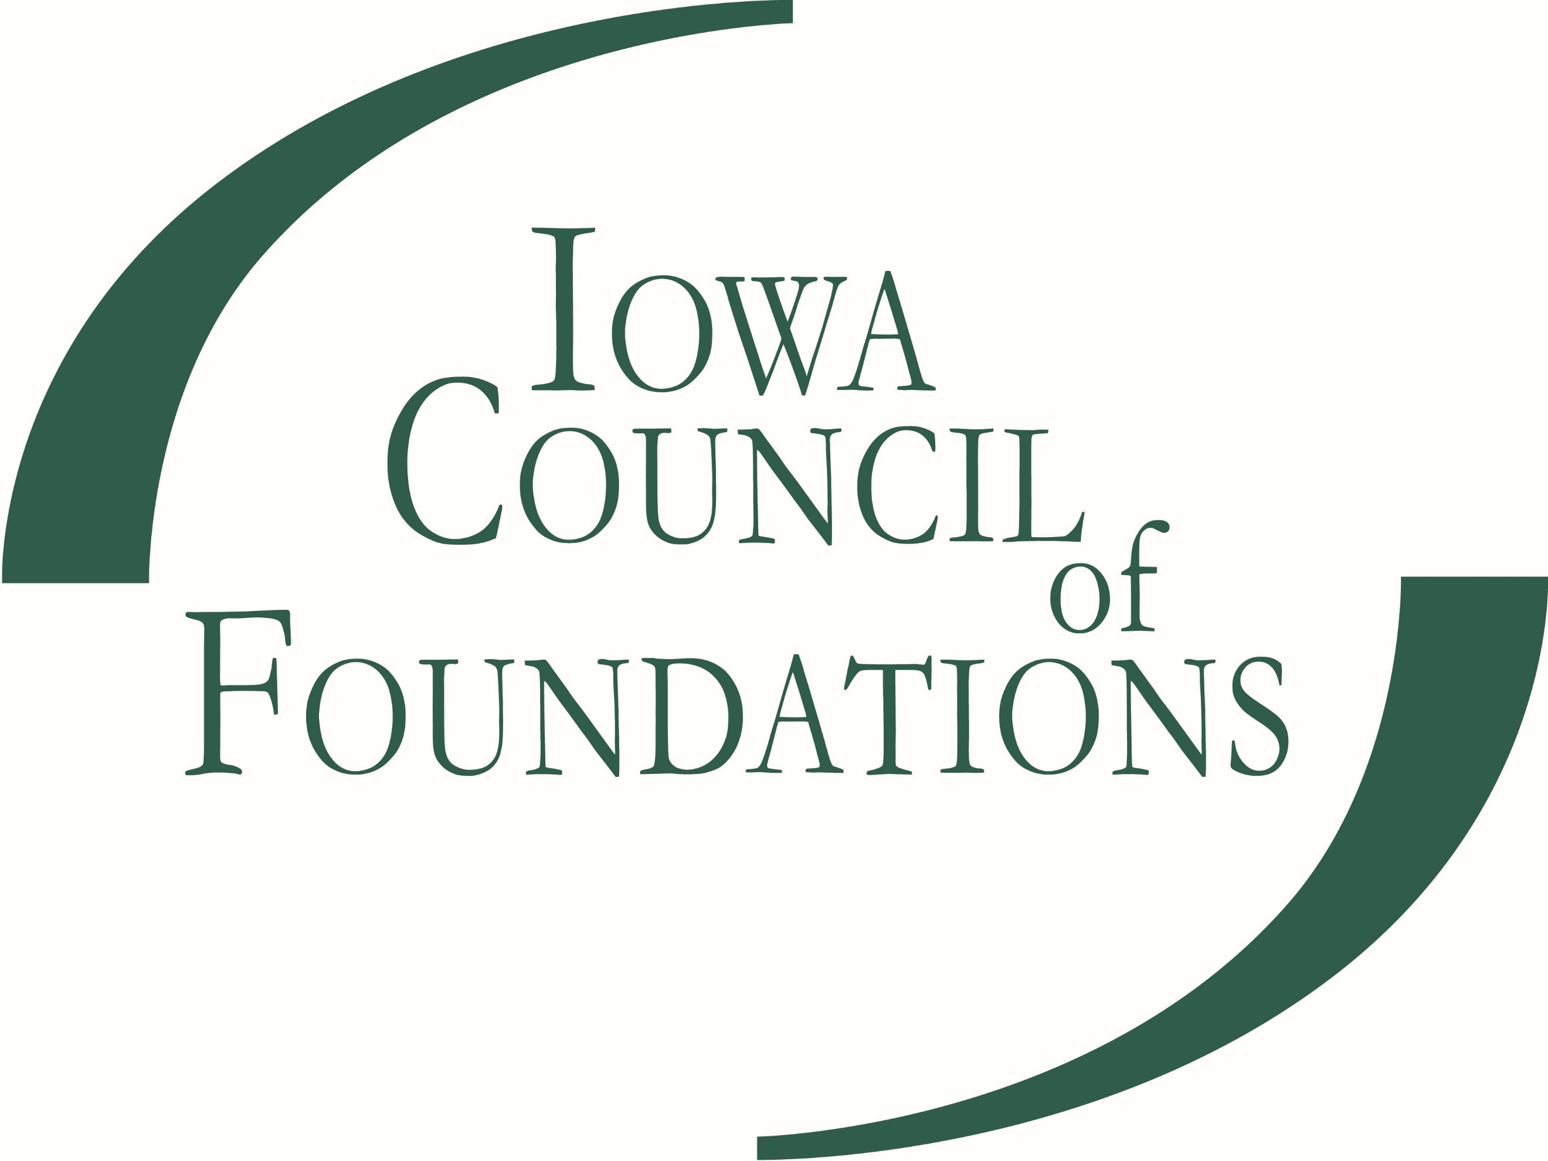
2020 GRANT APPLICATION FOR
AFFILIATE TRAINING ASSISTANCE

IOWA COMMUNITY FOUNDATIONS INITIATIVE

Since 2004, the ICoF has been designated as the state's Lead Philanthropic Entity, administrating the Iowa Community Foundations Initiative. In this role, we partner with the Iowa Economic Development Authority on two legislated programs that impact community foundations in our state: the County Endowment Fund Program and the Endow Iowa Tax Credit Program. The Iowa Community Foundations Initiative supports the network of community foundations and their affiliates across the state.

Iowa currently has more than 130 community foundations and a well-respected, effective network, which continues to propel the state as a national leader in the community foundation field. The majority of affiliates are operated by active volunteers in local communities that work with one of nine host community foundations serving as the legal entities and administrative supports for the affiliates. In an effort to support the education and training of community foundation and affiliate volunteers and staff around the state, the ICoF is making grants of up to $1,500 per year available per host community foundation.

These grants are to be used specifically for learning, educational, or training opportunities for affiliate volunteers and/or staff.

PLEASE COMPLETE THE FOLLOWING INFORMATION FOR ELIGIBILITY:

- Name of Community Foundation* requesting the grant dollars:
- List the affiliate counties that will participate in the training:

- Please provide a 2-3 sentence description of the program/activity the grant dollars will go toward and when and where it will take place:
- Can this program be opened up to other CF affiliate staff or volunteers?

- Can ICoF staff attend this program?

- Amount requested:

Contact Name: _____________________________________________________________
Street Address: _________________________________________________________________
City: ____________________________________ State: _____ Zip: ______________________
Phone: (____) _________________ Email: ___________________________________________

Please send your completed application to Kari McCann Boutell, President, Iowa Council of Foundations at: kmccann@iowacounciloffoundations.org.

