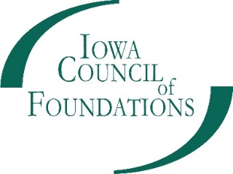
Community Foundation Capacity Building Grant Application
Host or Standalone Community Foundation:
Grant Contact:
Staff Contact for Affiliate Community Foundation Work (if different than above):
Phone:
Email:
Focus Areas (check or bold all that apply):
- Planning Activities
- Donor Development
- Board Development for Endowment Growth
- Strategic Relationships
- Internal Operations
- Professional Development
Amount Requested (between $1,000-$15,000): $
Affiliate Foundation Information (For Affiliates Only)
Affiliate Contact:
Phone:
Email:
Host Contact:
Phone:
Email:
To certify that you worked in partnership with your Host to complete this application, please check here:
Project Information
Overview:
- Describe the organizational challenge or opportunity that, if addressed, would have a clear positive impact on your organization’s ability to build endowments or grow endowed funds. You may wish to focus on the question: “What is the best way to invest in our organization to increase positive results in our efforts to build endowments?”

- Describe your proposed strategy or plan for building your organization’s capacity to support endowment building/growth within your organization. Include the set of activities you will undertake and/or the plan this aligns with for strengthening your endowment building work.

- How will you track your progress and what will success look like? Please include clearly defined development goals and measures.

- At the end of this grant, how will your organization look and work differently? Please be as specific as possible.

- Include a Project Budget and description of expense line items, additional funds leveraged, and supporting matching funds. You can download a Project Budget Template at http://iowacounciloffoundations.org/grant-opportunities/.

Submit all documents via email to info@iowacounciloffoundations.org by 5 pm on March 30, 2020.

