Registering another contact through online self-service
A contact can register another contact for an event by logging in then entering the other contact's email address during the registration process.
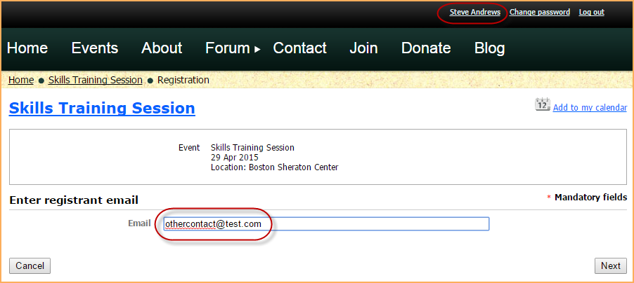
If you do not log in, the system will assign the first registration and its invoice to the contact with that email address, assuming it already exists in your database. For subsequent registrations during the same browser session, invoices will be assigned to this first contact and the registrations will be associated with the email addresses you enter. To avoid this, close your browser after each registration or log in before registering.
If the contact doing the registration is already registered for an event, they can click the New registration button after clicking the Register button from the event details.
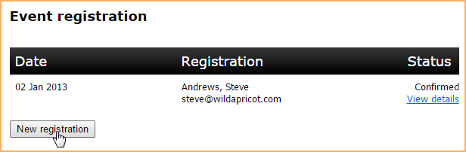
In either case, the contact doing the registering will be invoiced for the registration fee.

